MAWLANA BHASHANI SCIENCE AND TECHNOLOGY UNIVERSITY
SANTOSH, TANGAIL-1902



DEPARTMENT OF INFORMATION AND COMMUNICATION TECHNOLOGY
Lab Report

Lab Report No : 03
Lab Report on : From Code to Cloud: Linking VS Code with GitHub and Publishing a Live
Website
Course Title : Web Application Development Lab
Course Code : ICT-3204
Submitted By | Submitted To
Name: Kuldip Saha Mugdha  ID: IT-22018  3rd Year, 2nd Semester  Session: 2021-2022  Dept. of ICT, MBSTU | Mr. Md. Anowar Kabir  Lecturer  DEPARTMENT OF INFORMATION AND COMMUNICATION TECHNOLOGY  MAWLANA BHASHANI SCIENCE AND TECHNOLOGY UNIVERSITY

Date of Performance: 8/11/25 Date of Submission: 24/11/25
Introduction:
In modern software development, cloud-based version control and deployment systems are very essential. Git and GitHub are the most widely used platforms for managing code, tracking changes, and collaborating with developers. GitHub Pages additionally allows the developers to host static websites at no cost.
This experiment demonstrates the complete workflow of building a simple website in VS Code, integrating it with Git, pushing the project to GitHub, and finally deploying it as a publicly accessible live website using GitHub Pages.
Objectives:
- To learn how to initialize and manage a Git repository from VS Code.
- To understand and apply Git commands such as init, add, commit, and push.
- To upload (publish) a project to GitHub from a local machine.
- To deploy a fully functional live website using GitHub Pages.
- To understand the workflow of cloud-based code hosting and website deployment.

Required Tools & Technologies:
- Visual Studio Code (VS Code)
- Git (version control system)
- GitHub Account
- Web browser
- Basic HTML Project (index.html)
- Internet Connection

Theory:
1.Git:
Git is a distributed version control system that records changes made to files. It allows developers to revert to earlier versions, collaborate without conflict, and maintain a complete history of a project.

2. GitHub
GitHub is a cloud platform that hosts Git repositories. It supports collaboration, code reviews, issue tracking, and cloud storage for projects.

- GitHub Pages:
GitHub Pages is a free static web hosting service. It allows any repository containing an index.html file to be published as a live website accessible globally.

GitHub Pages workflow:
Local Code → GitHub Repository → GitHub Pages → Public Website

4. Importance of index.html:
GitHub Pages automatically loads index.html as homepage. If this file is missing, the website will show 404 Not Found.

Experimental Procedure:
Step-1: Create folder in vs code and html file name ”index.html” inside it and open this folder in vs code.
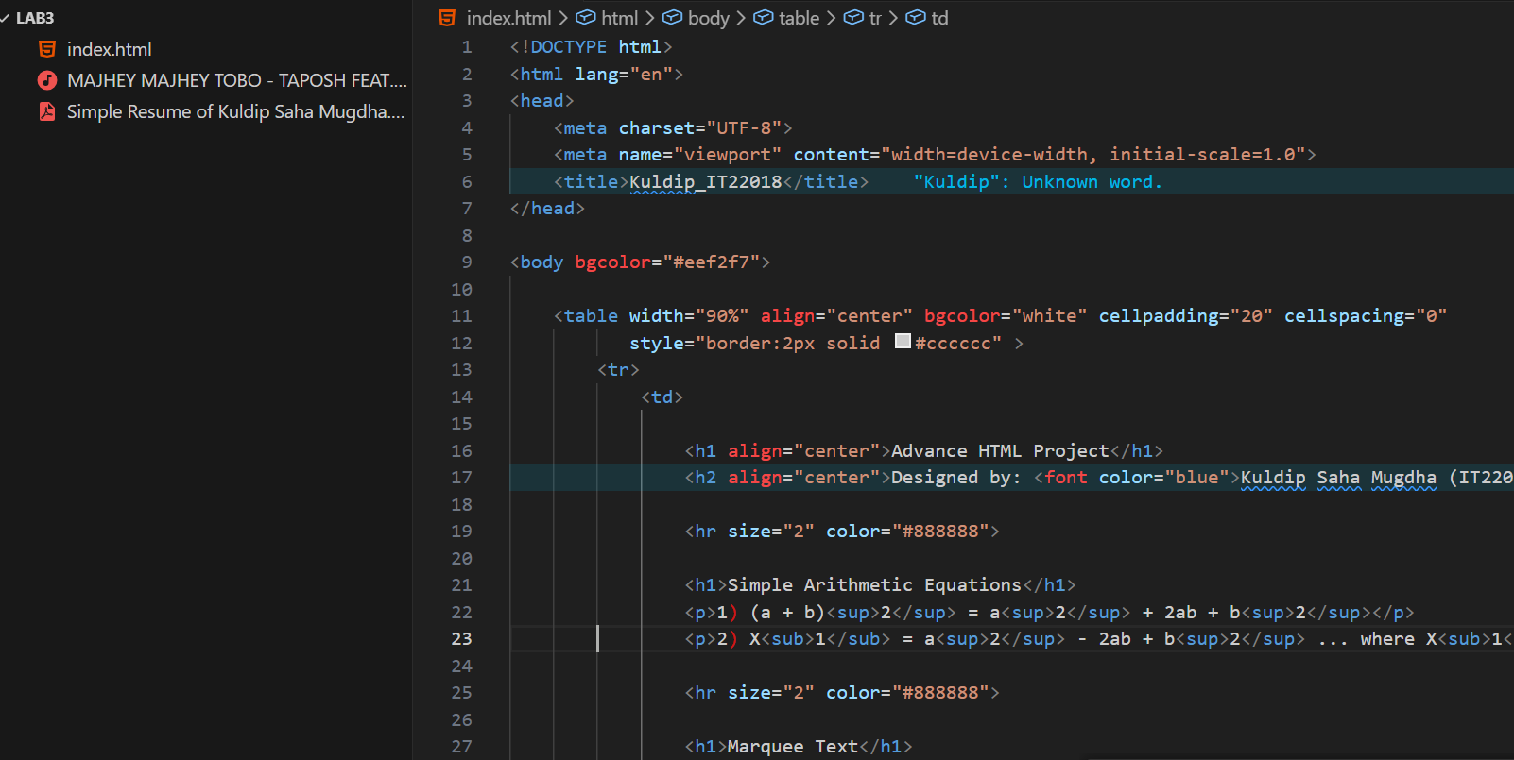
Step-2: Initialize Git. Open the terminal in VS Code and type: ‘git init’

Step 3: Check Git Status: ‘git status’

Step 4: Stage All Files: ‘git add .’

Step 5: Commit the Files : git commit -m "Initial commit"
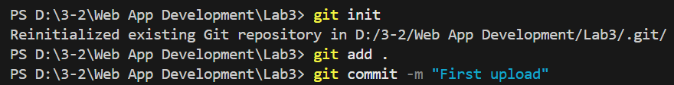

Step 6: Create a GitHub Repository:
GitHub → New Repository → Enter name → Create
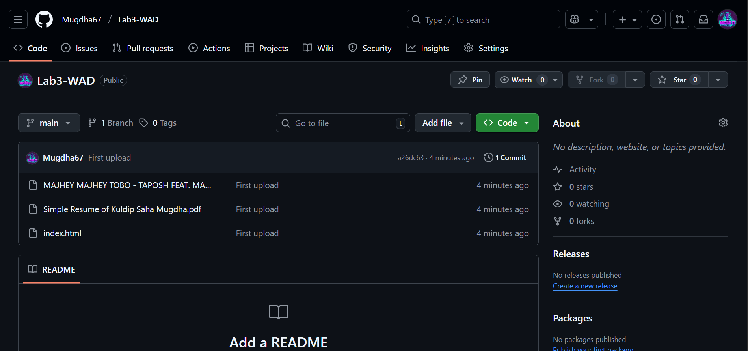

Step 7: Connect VS Code to GitHub Repository
Copy and paste the following commands given by GitHub:
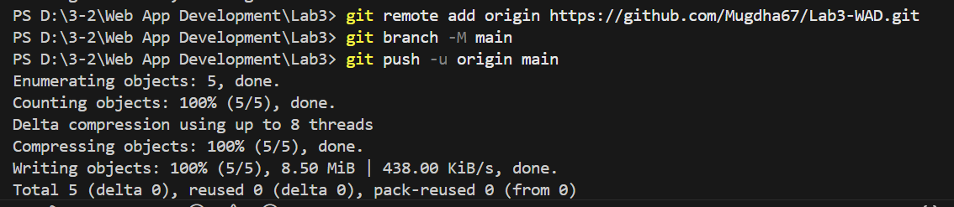
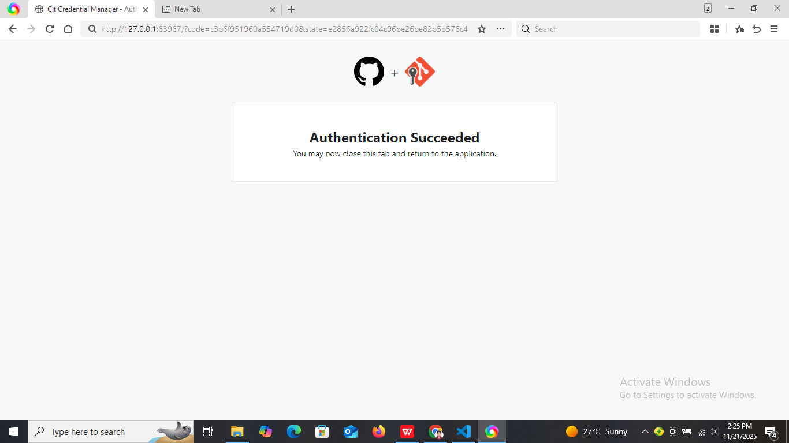
Step 8: Enable GitHub Pages
Go to:
Repository → Settings → Pages

Configure:
Source: main
Folder: /(root)
Click Save.
GitHub had generated a website link like:
https://mugdha67.github.io/Lab3-WAD/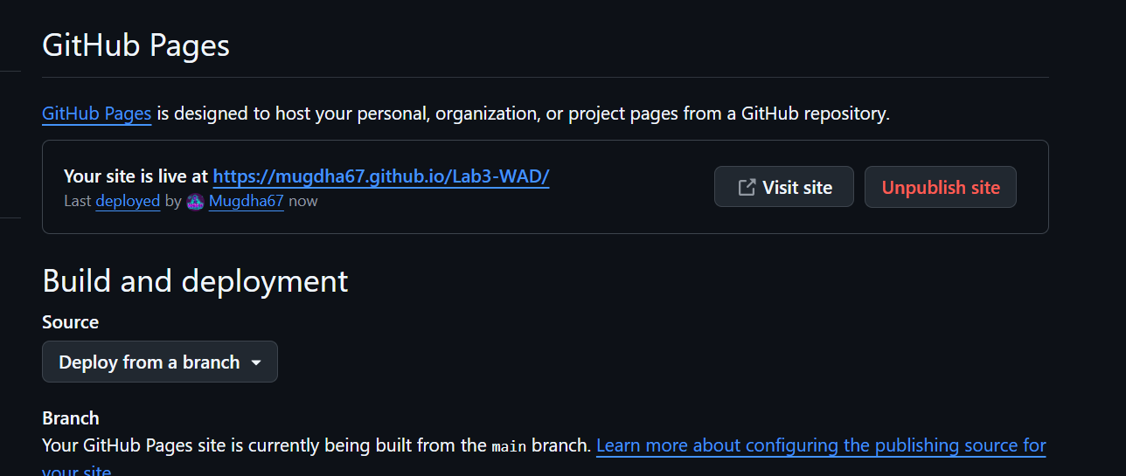
Step 9: View the Live Website:
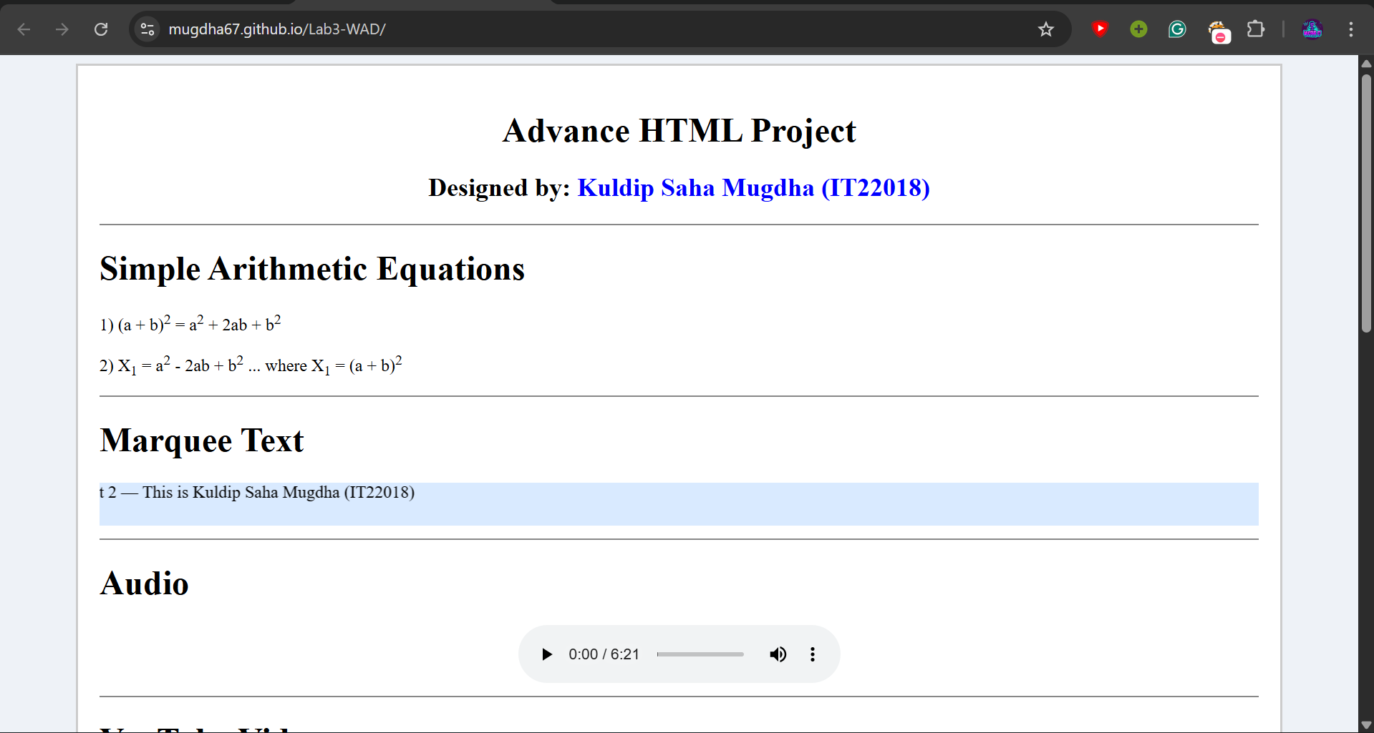
Observations:
- VS Code successfully connected with GitHub.
- Git commands tracked and uploaded files properly.
- After enabling GitHub Pages, the live link was generated automatically.
- The website became accessible globally without any hosting cost.

Results:
The HTML project was successfully uploaded from VS Code to GitHub and published as a fully functional live website using GitHub Pages. This demonstrates the complete workflow of cloud-based version control and deployment.

Discussion:
This experiment highlights the importance of Git and GitHub in modern software development.
Key points observed:
- Git enables efficient version control and prevents data loss.
- GitHub provides a cloud platform for collaboration and code management.
- GitHub Pages simplifies the deployment process, requiring no external hosting.
- Naming the file index.html is crucial for successful website loading.

Conclusion:
This experiment successfully demonstrated how to create a website in VS Code, manage the project using Git, upload it to GitHub, and publish it online through GitHub Pages. By completing these steps, we learned the essential workflow of modern web development—version control, cloud hosting, and live deployment. The lab strengthened our understanding of how code moves from a local machine to the cloud and becomes accessible as a real website.

